1) Starting the mysql by giving username as root and password as cloudera.

mysql -u root -pcloudera

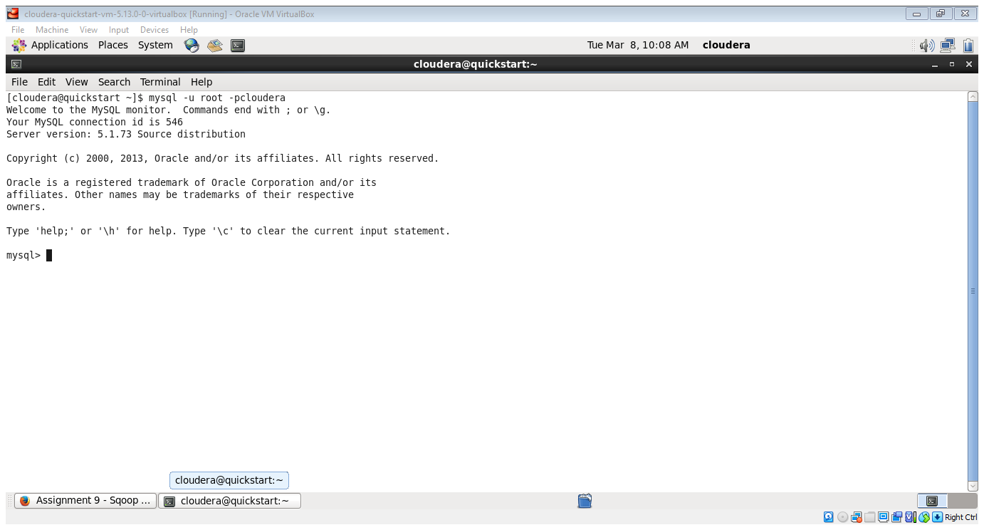

**show databases;**

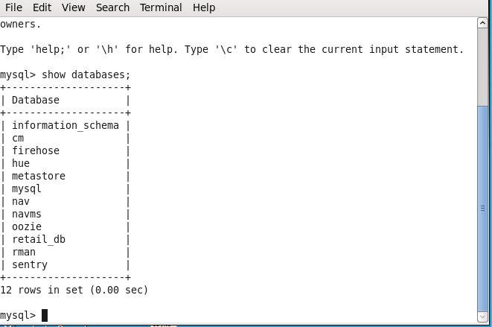

**Use retail_db;**

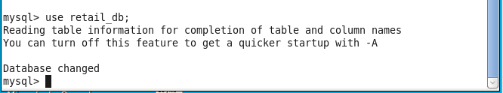

**Show tables;**

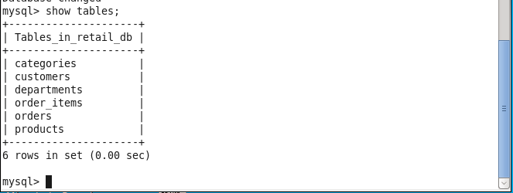

**Select * from customers;**

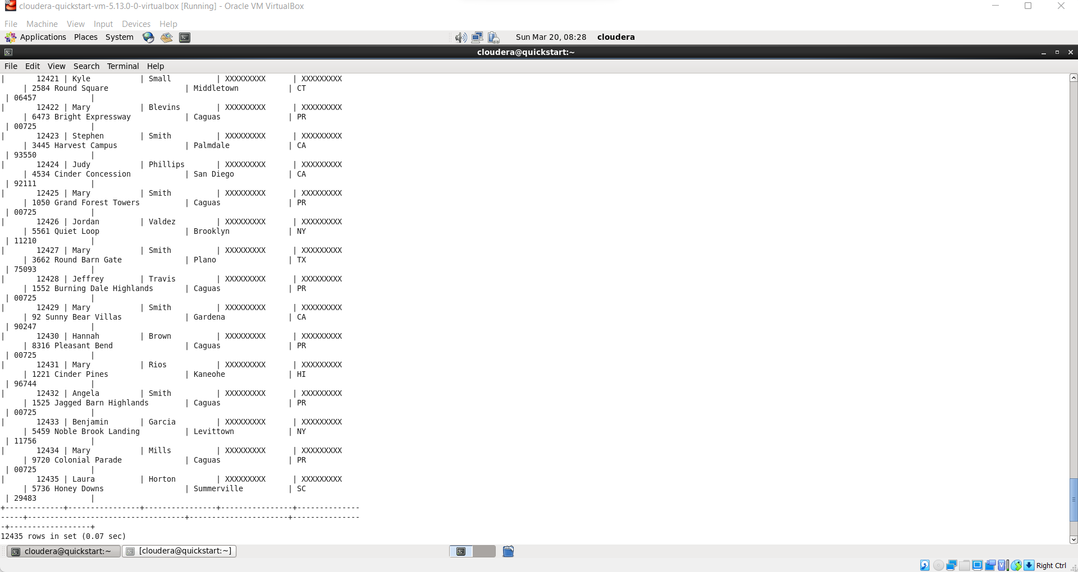

**Select * from departments;**

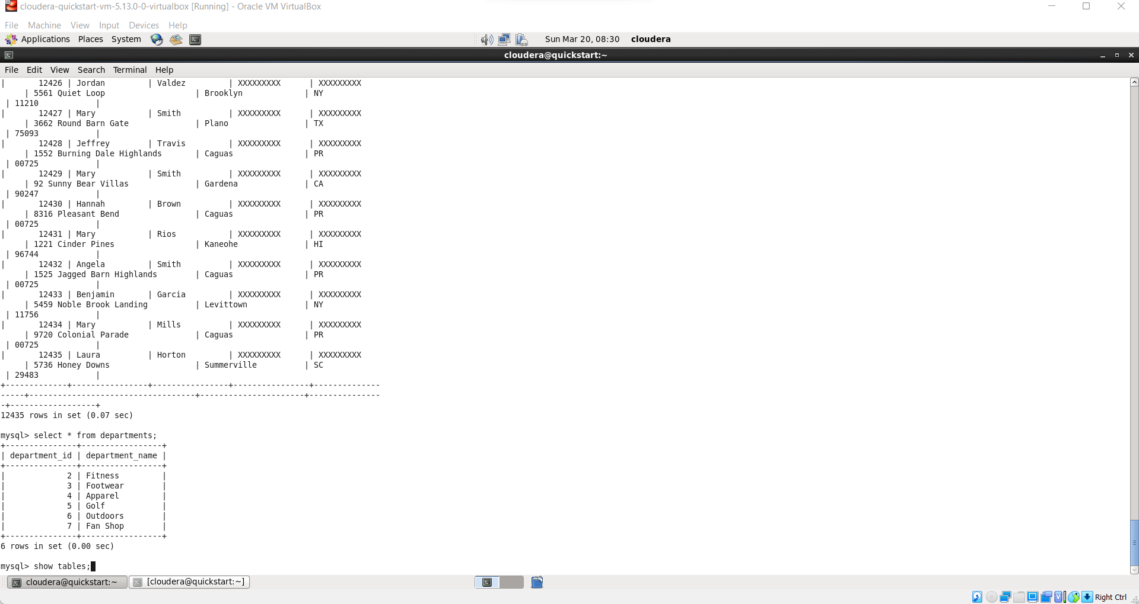

**Open the new terminal for running command for sqoop.**

**Hostname-f**

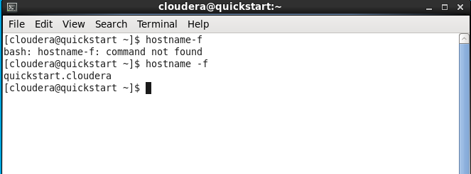

**sqoop list-databases --connect jdbc:mysql://quickstart:3306/ --password cloudera --username root;**

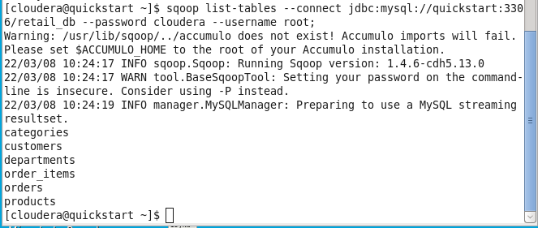

sqoop list-tables --connect jdbc:mysql://quickstart:3306/retail_db --password cloudera --username root --table departments;

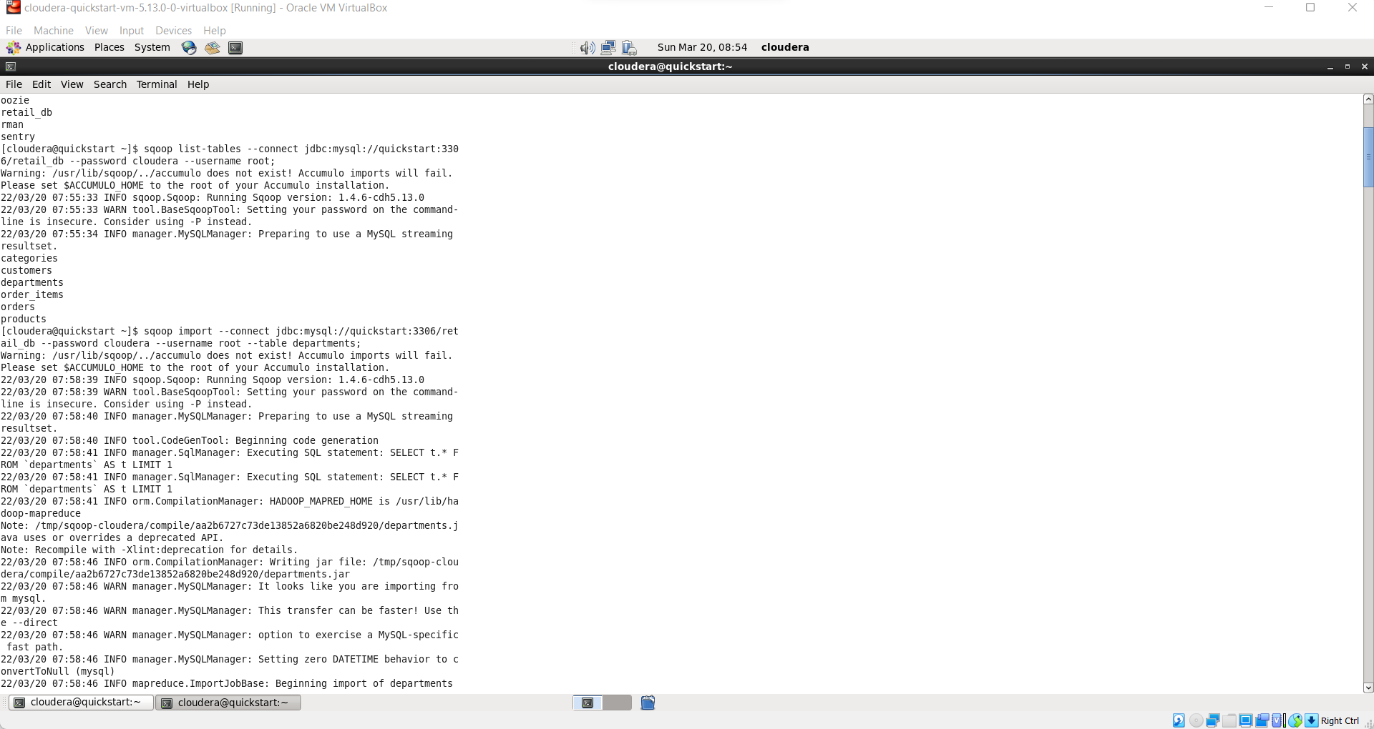

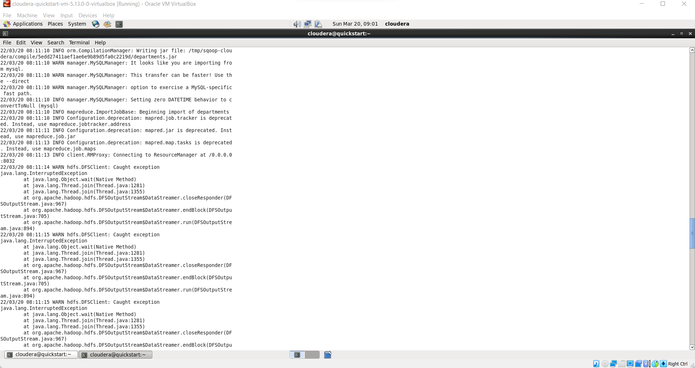

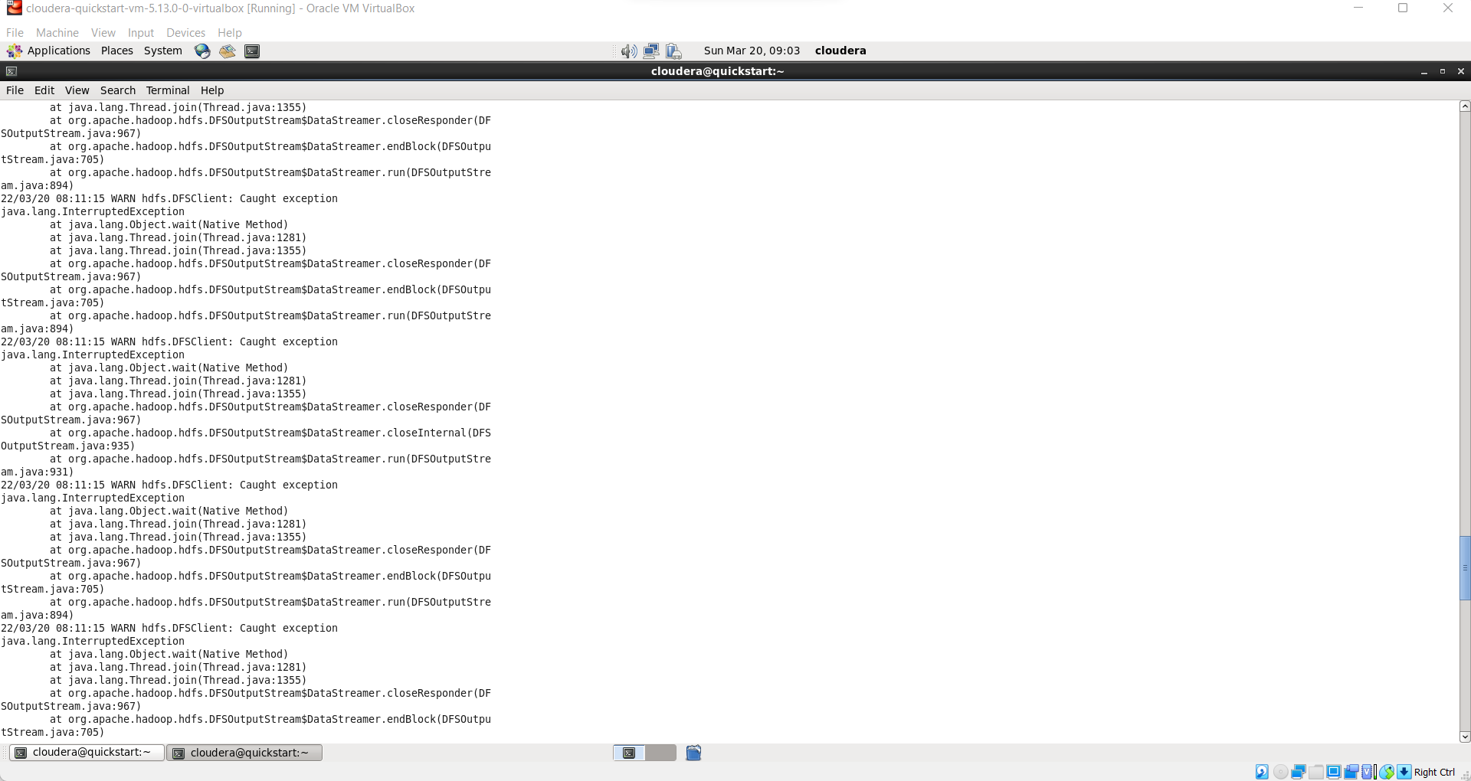

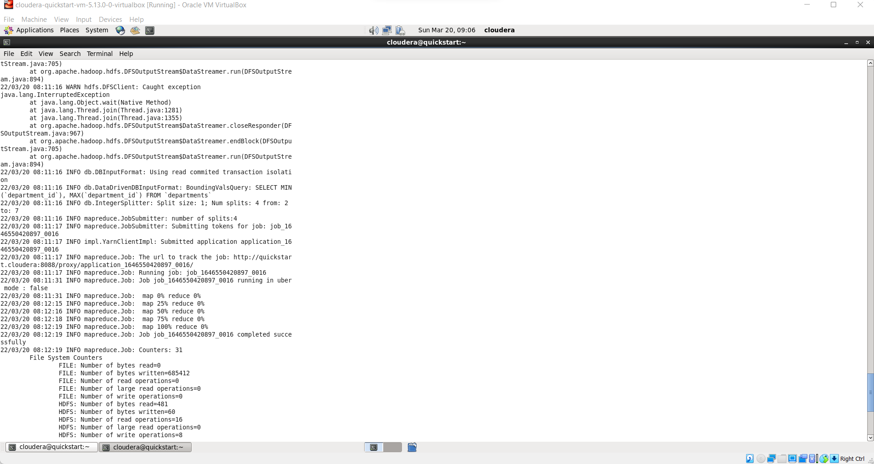

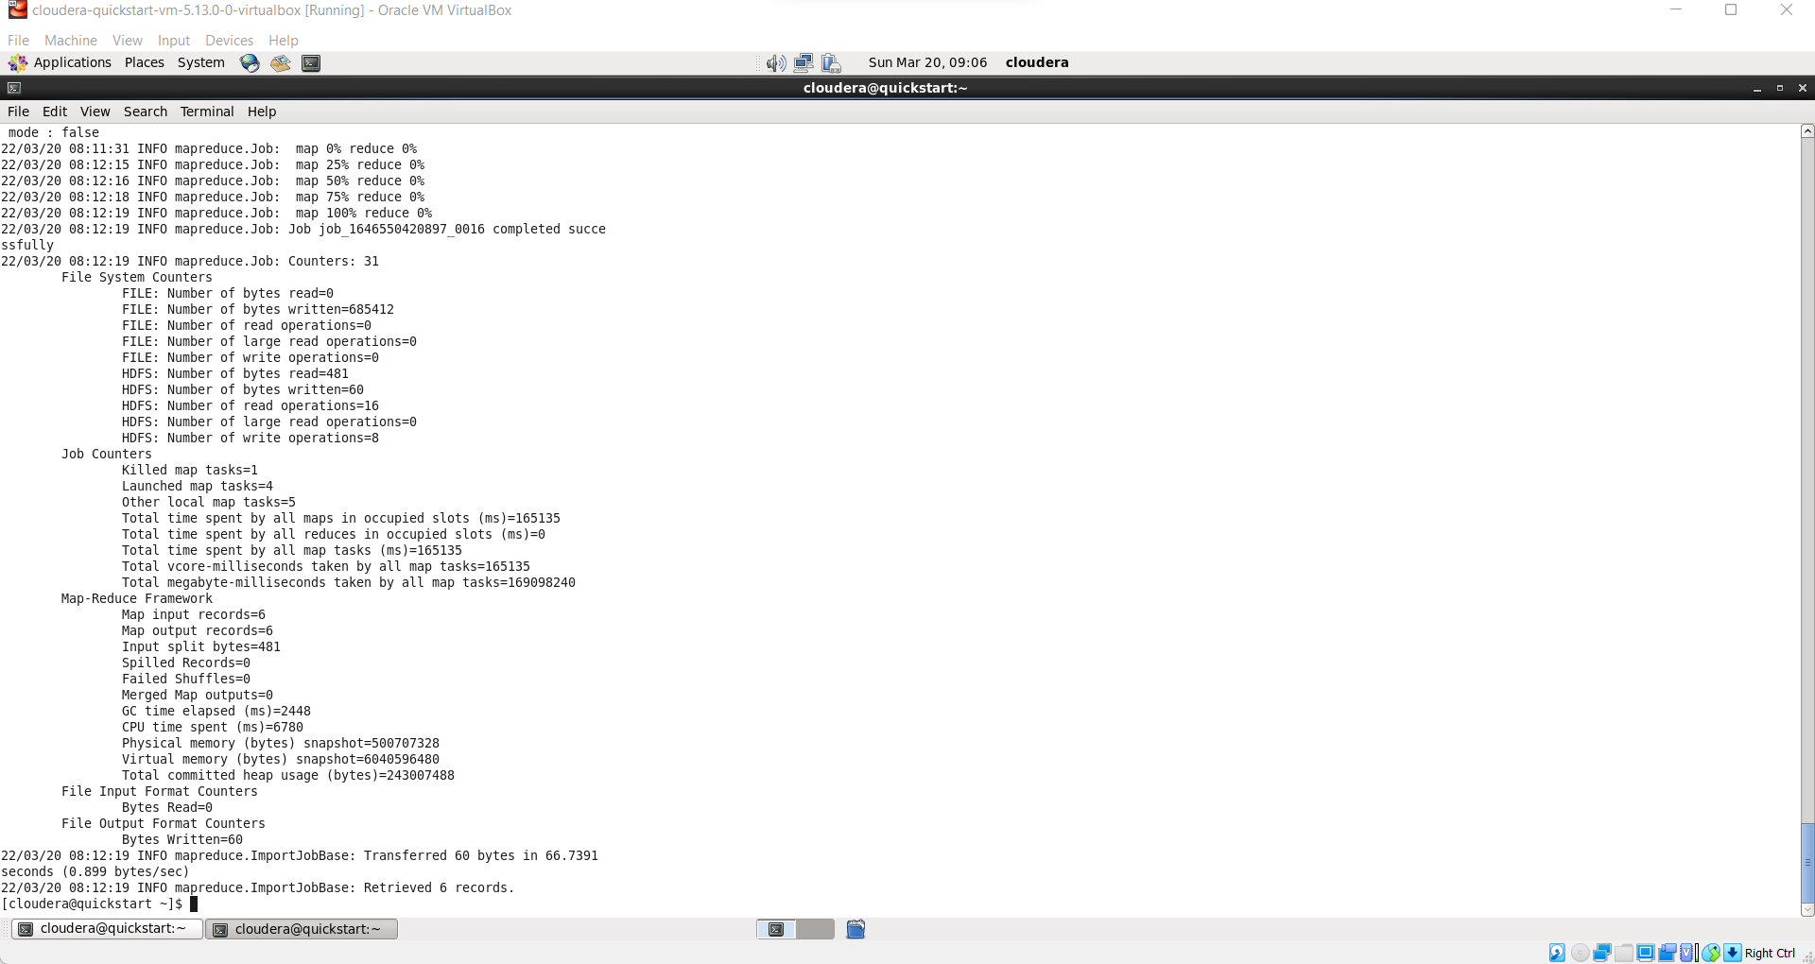

**hadoop fs –ls**

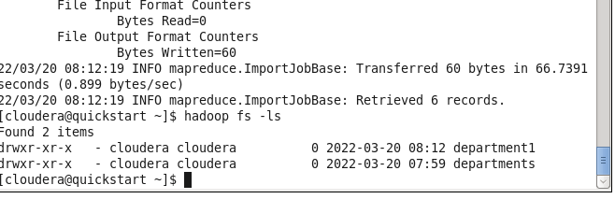

**hadoop fs –ls deparments;**

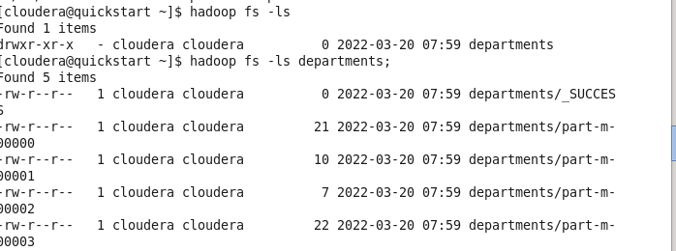

**hadoop fs -cat /user/cloudera/departments/part-m-00000**

**hadoop fs -cat /user/cloudera/departments/part-m-00001**

**hadoop fs -cat /user/cloudera/departments/part-m-00002**

**hadoop fs -cat /user/cloudera/departments/part-m-00003**

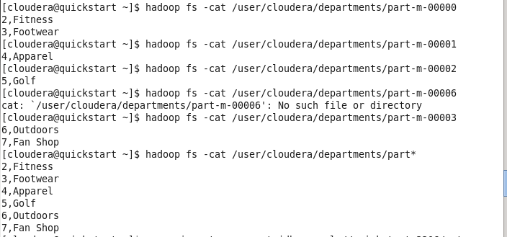

**hadoop fs -cat /user/cloudera/departments/part\***

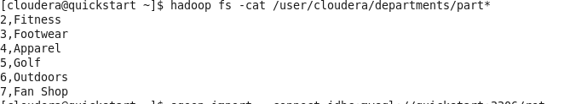

**sqoop import --connect jdbc:mysql://quickstart:3306/retail_db --password cloudera --username root --table departments --target-dir /user/cloudera/department1**

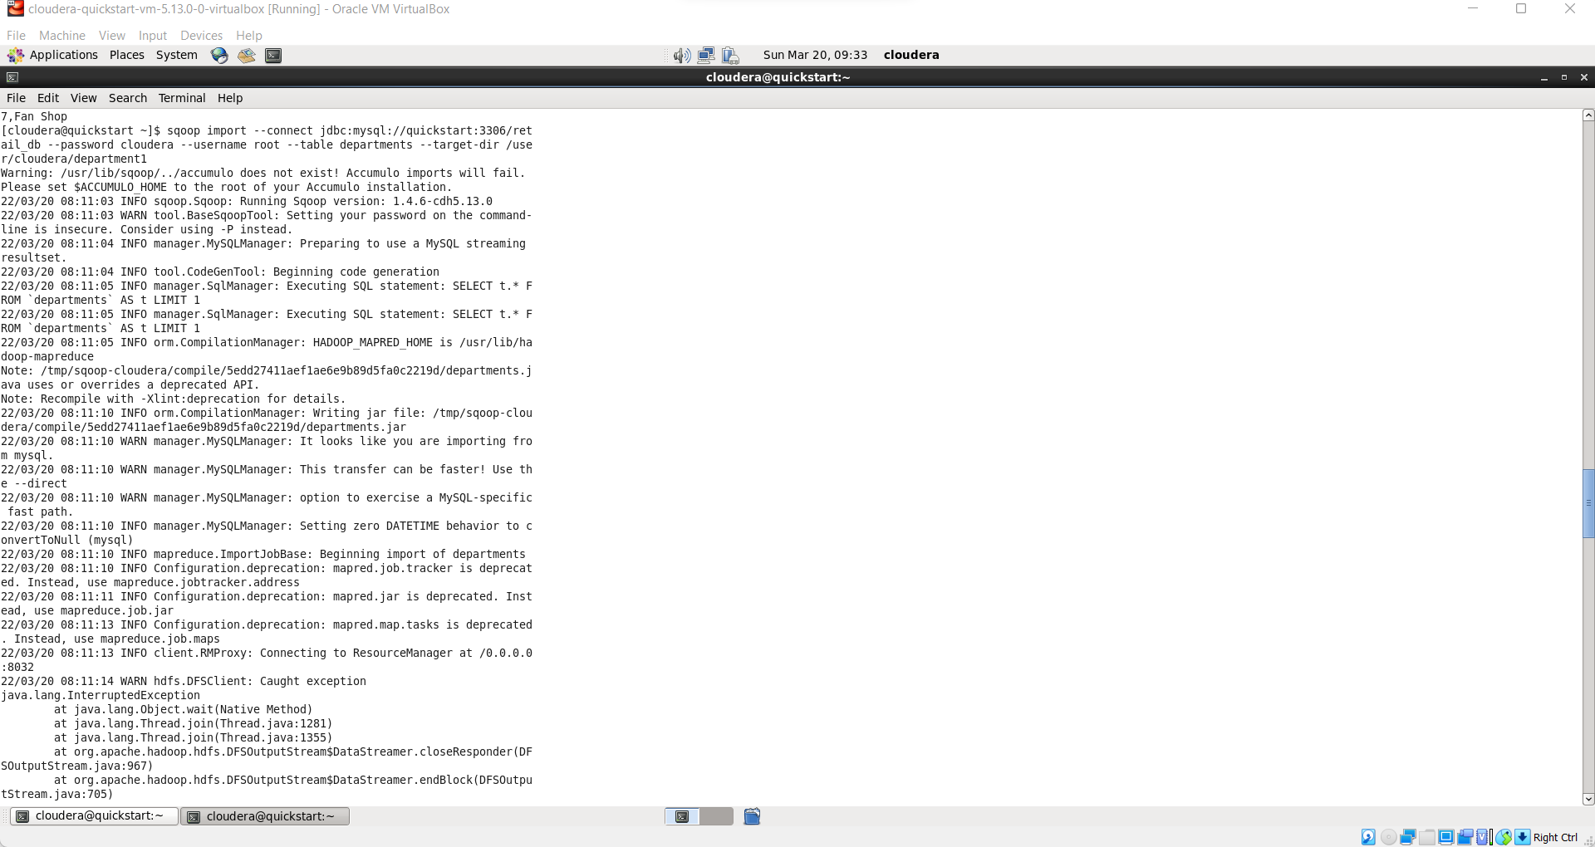

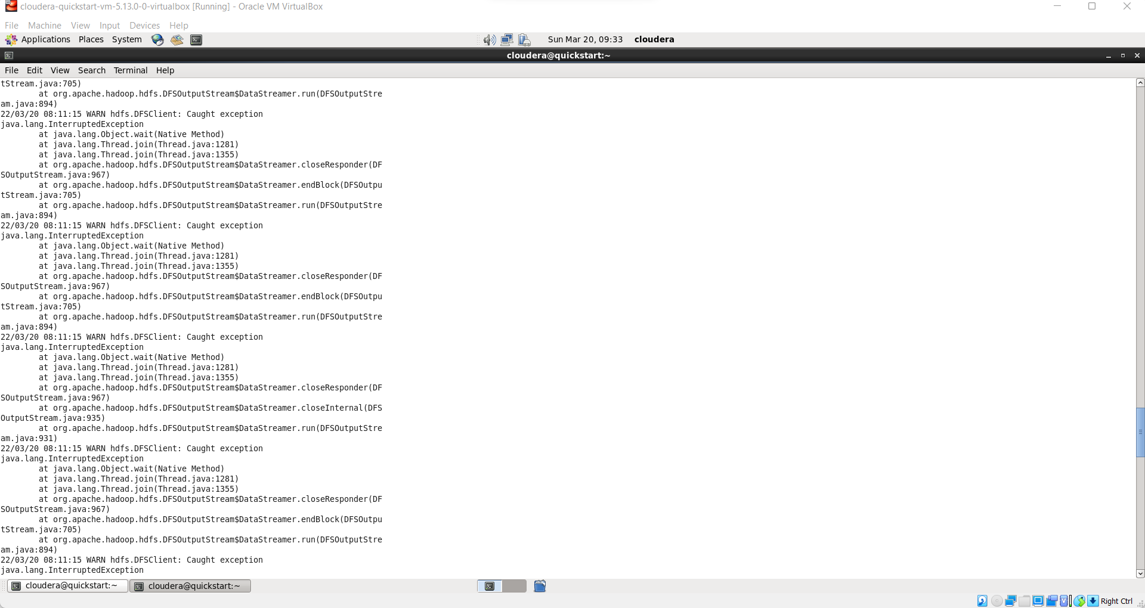

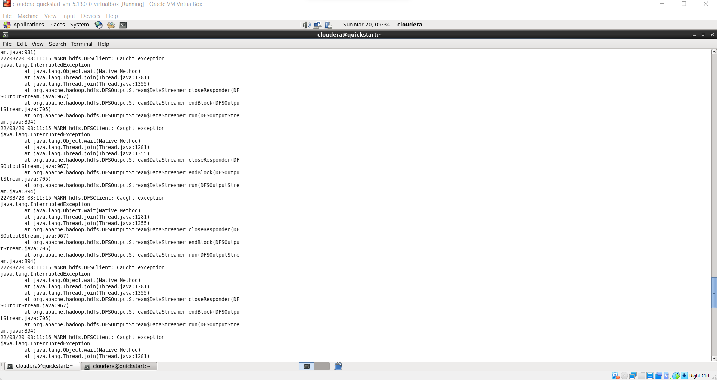

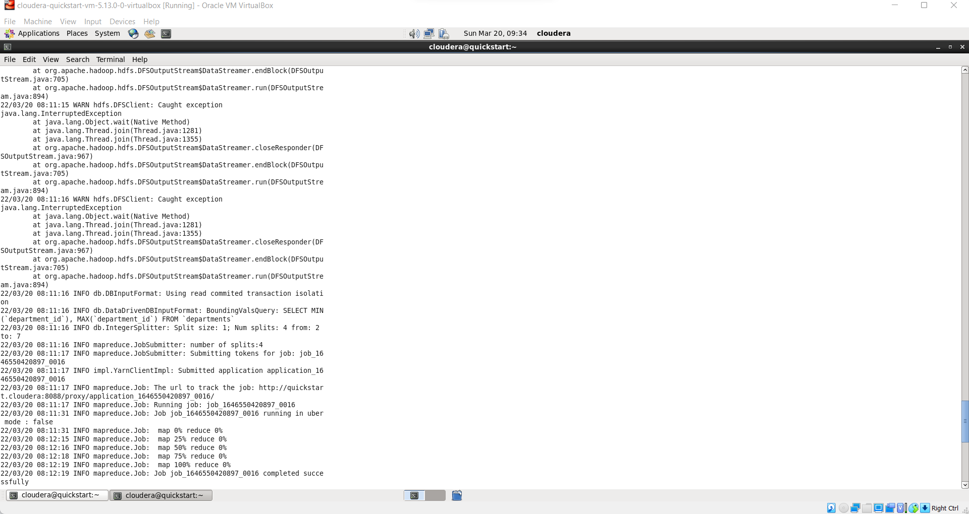

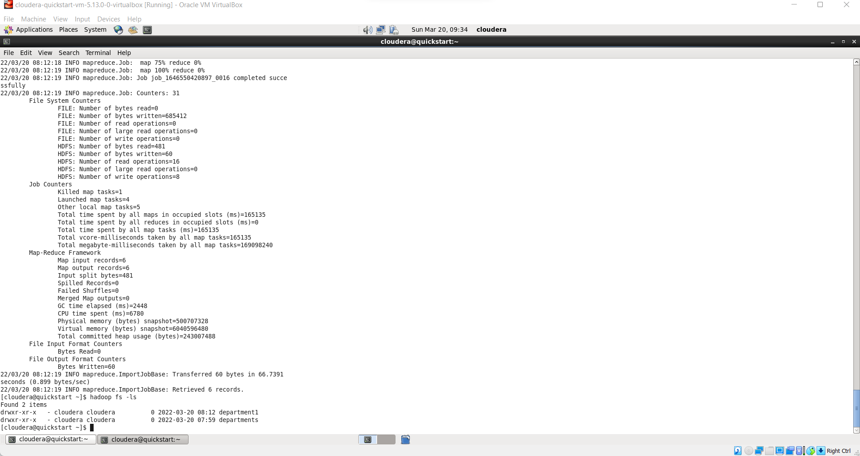

**As we can see 6 records are retrived successfully.**

**hadoop fs -ls**

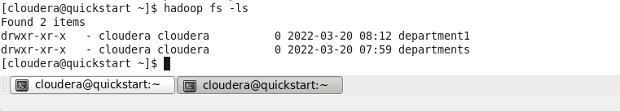

**hadoop fs -cat /user/cloudera/department1/part\***

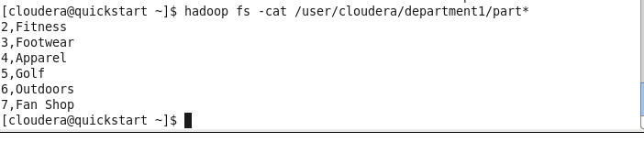

**sqoop import --connect jdbc:mysql://quickstart:3306/retail_db --password cloudera --username root --table departments --where "department_id>4" --target-dir/user/cloudera/department2;**

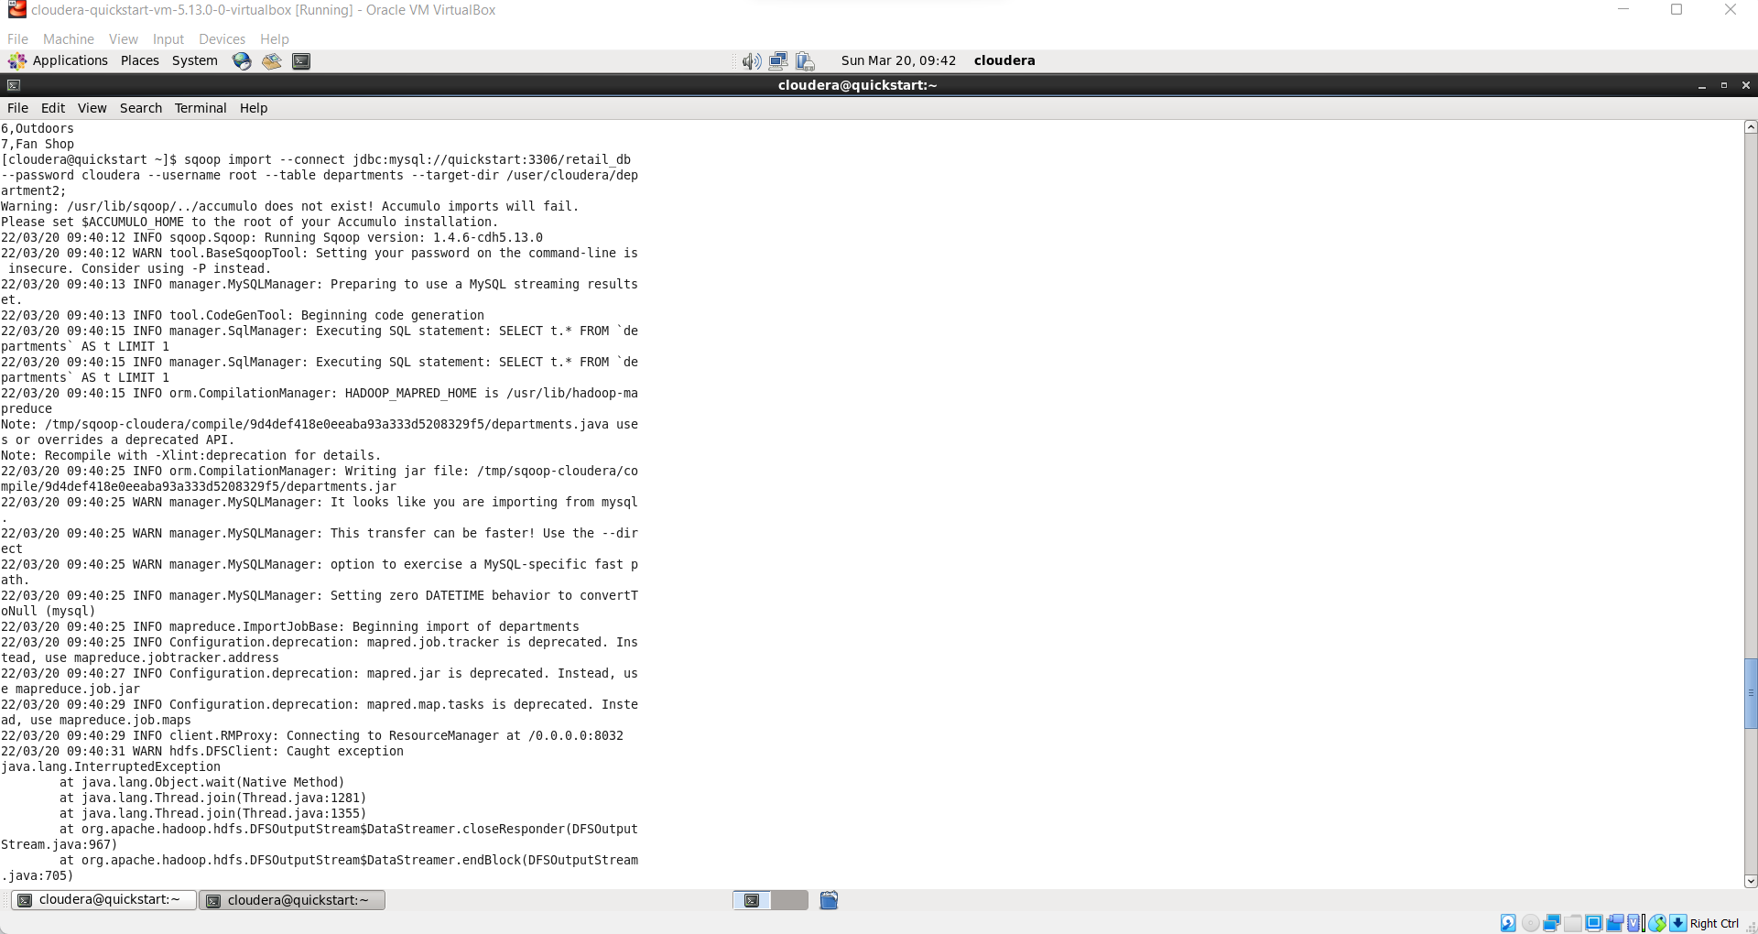

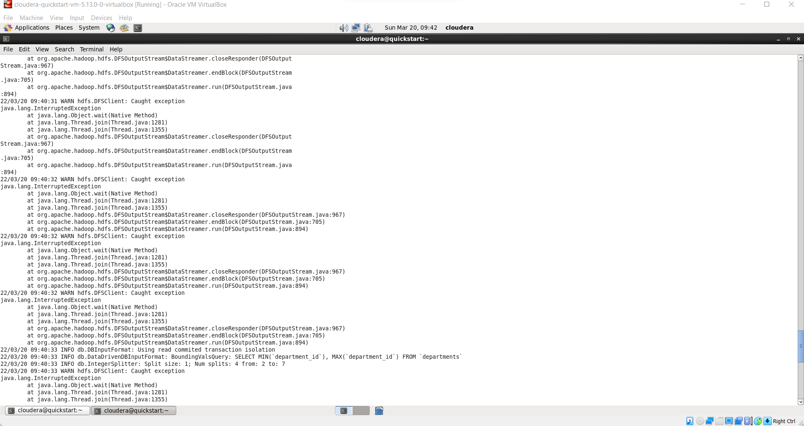

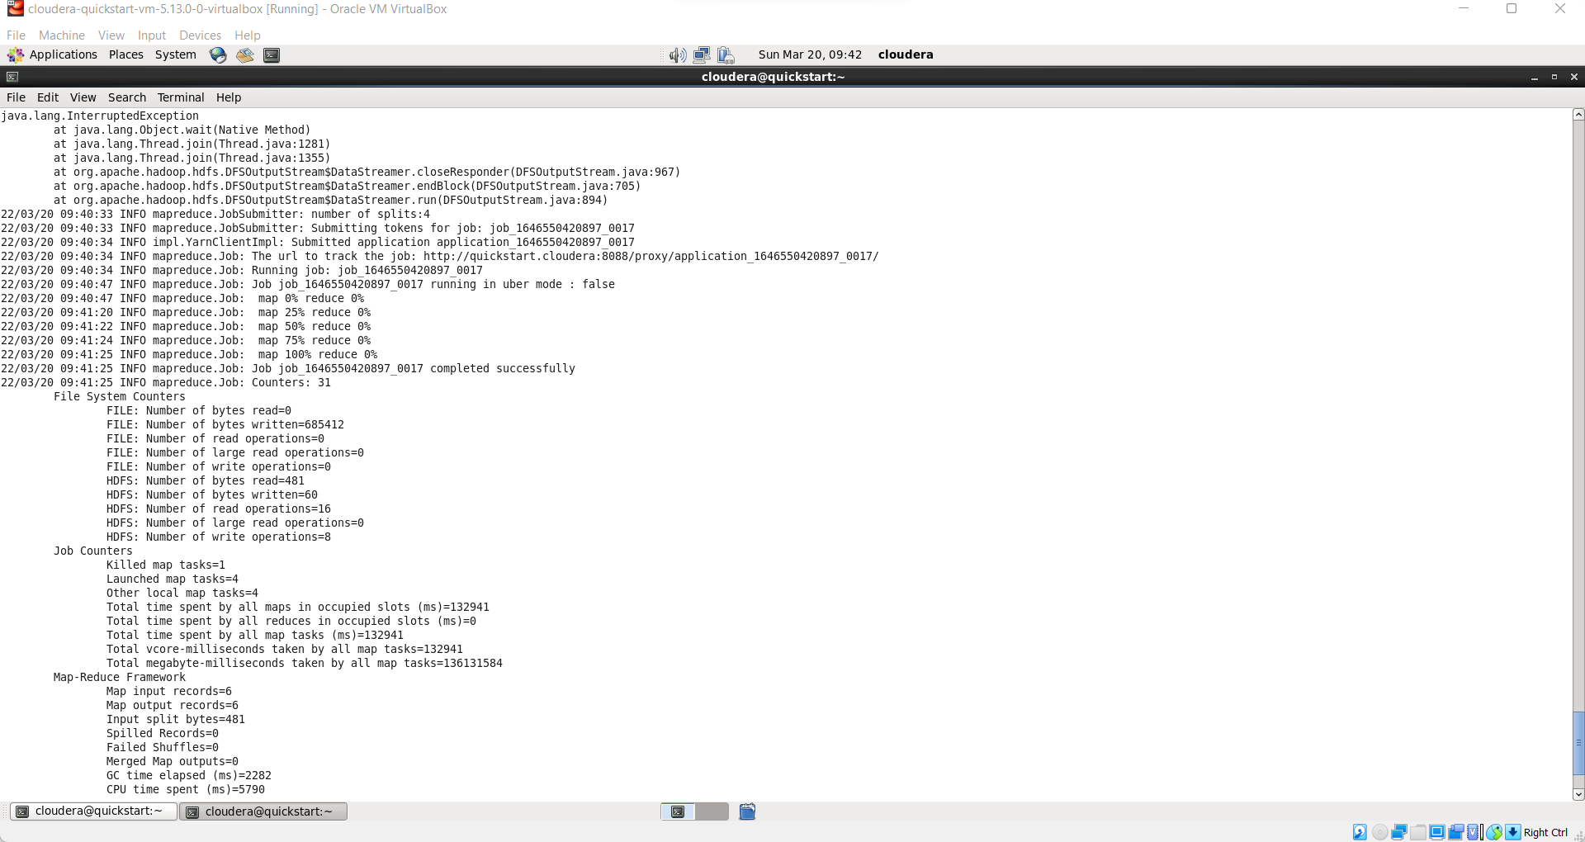

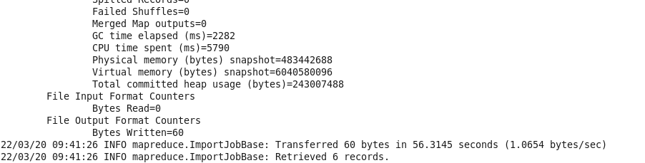

**As we can see 3 records are retrieved successfully**.

hadoop fs -ls /user/cloudera/department2

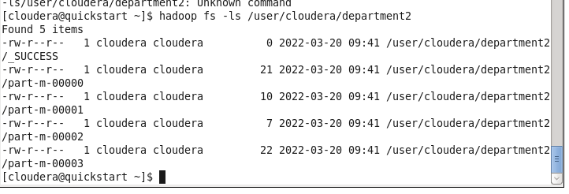

**hadoop fs -cat /user/cloudera/department2/part\***

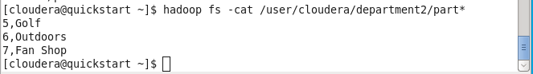

Now we will see the Export command. So what the export tool does is it will export the data from our hdfs to the RDBMS. So for that we need to have some table in mysql with some records so for that we will now move to mysql.

create table dpt(department_id int not null auto_increment, department_name varchar(50) not null, primary key(department_id));

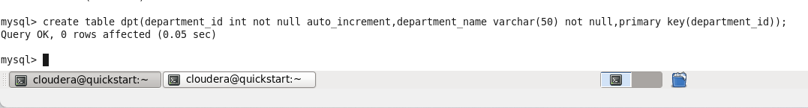

**Select * from dpt;**

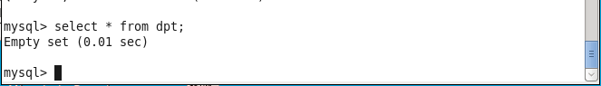

Now we will exporting the data from the hdfs to dpt table of mysql. Now we will move to the sqoop terminal.

sqoop export --connect jdbc:mysql://quickstart:3306/retail_db --password cloudera --username root --table dpt --export-dir /user/cloudera/department2;

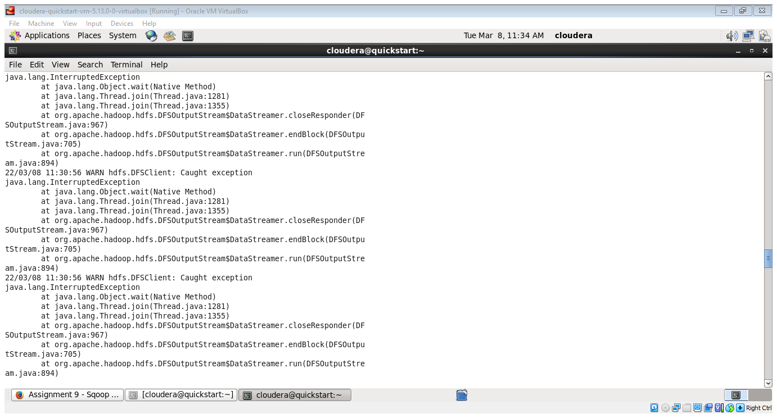

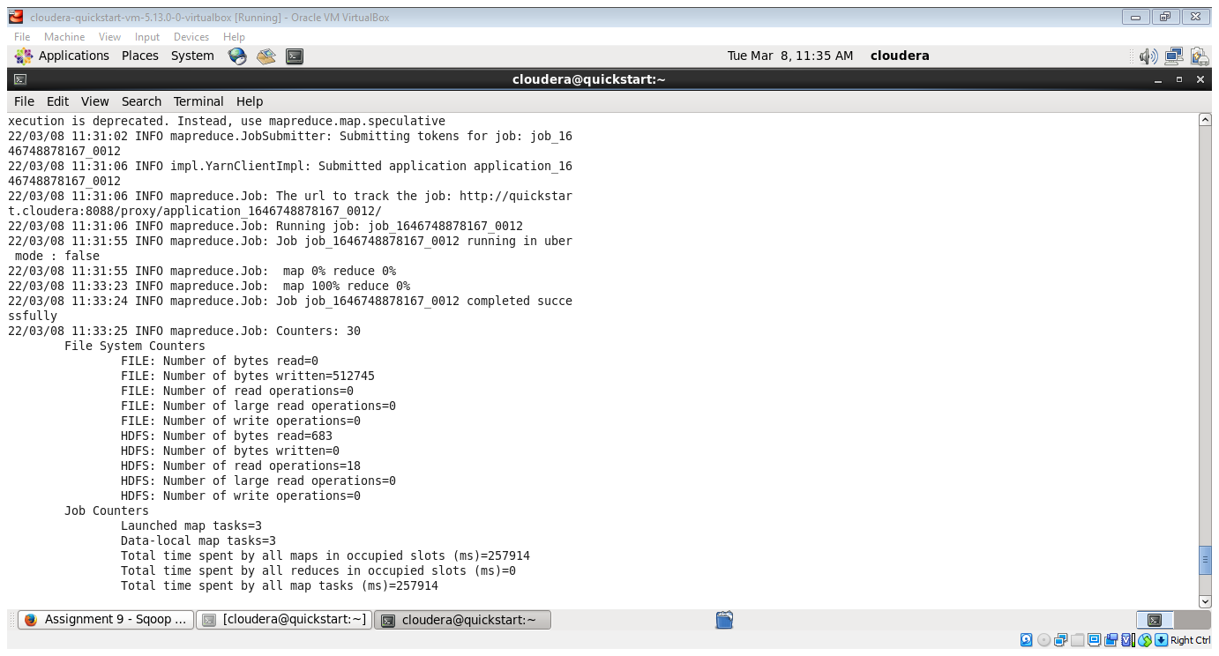

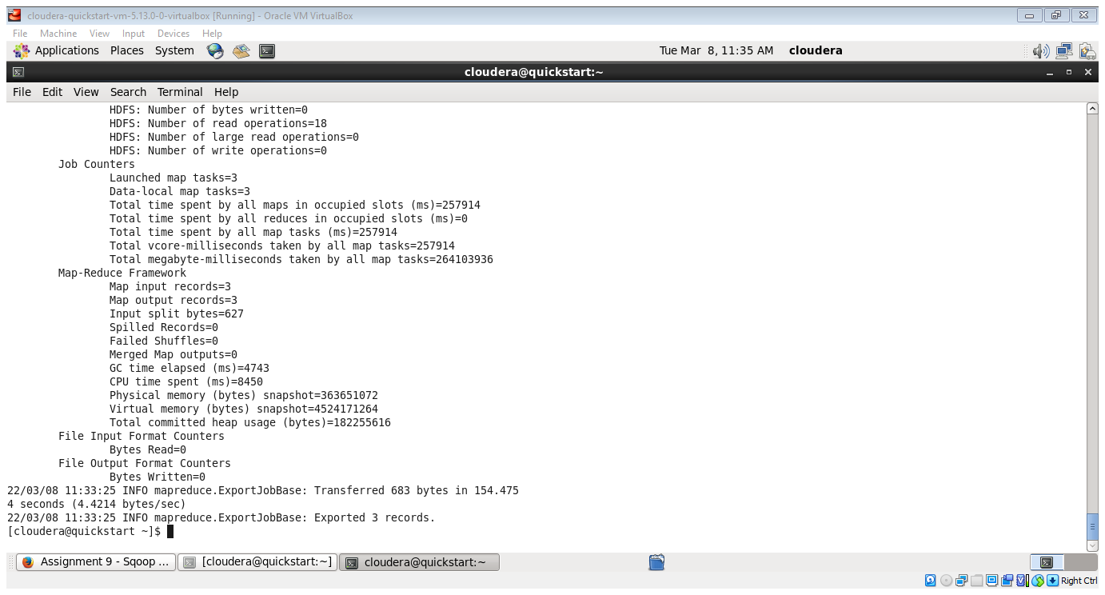

**Select * from dpt;**

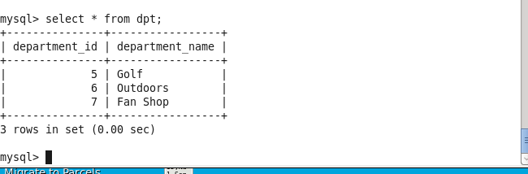

As we can see these 3 records which are present in department2 table are successfully exported inside the dpt table of mysql.